Dylan Gallup

CS260: Object Oriented Programming

Professor Tevis Boulware

Week 5 Assignment

Sources: Professor Tevis Boulware

**UML Class/Object Diagram**

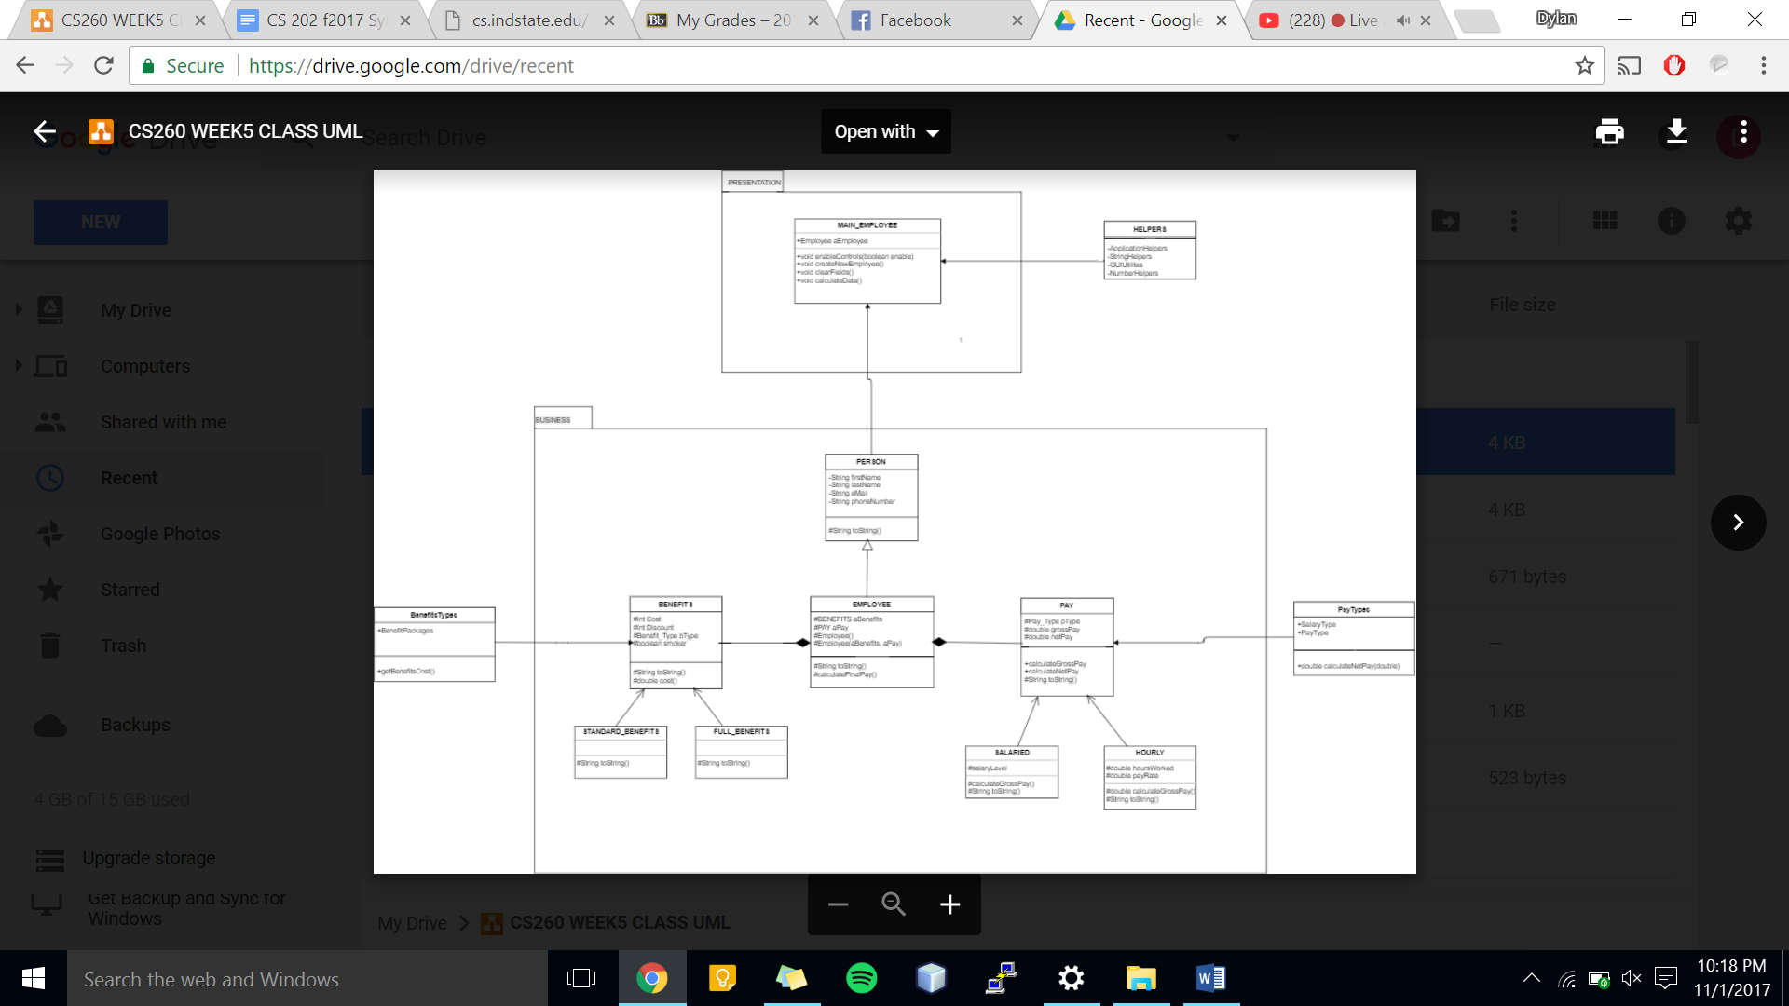

**Test Cases**

Test Case Scenarios

|  |  |  |  |  |  |
| --- | --- | --- | --- | --- | --- |
| **#** | **Purpose** | **Input Values** | **Expected Results** | **Pass/Fail** | **Comments** |
|  | Check bounds | All valid inputs except  txtFirstName = NULL | Error Prompt to appear | **Pass** |  |
|  | Check bounds | All valid inputs except txtLastName = NULL | Error Prompt to appear | **Pass** |  |
|  | Check bounds | All valid inputs except  txtHours = -1 | Error Prompt to appear | **Pass** |  |
|  | Check bounds | All valid inputs except  txtHours = 76 | Error Prompt to appear | **Pass** |  |
|  | Check bounds | All valid inputs except  txtPayRate = 7.00 | Error Prompt to appear | **Pass** |  |
|  | Check bounds | All valid inputs except  txtPayRate = 66.00 | Error Prompt to appear | **Pass** |  |
|  | Check Jbutton: Calculate | All valid inputs | Prints out Employee Data | **fail** |  |
|  | Check Jbutton: Exit | Click on Jbutton | Prompt to ask user to exit and closes program | **Pass** |  |